Map of Asia in 1914

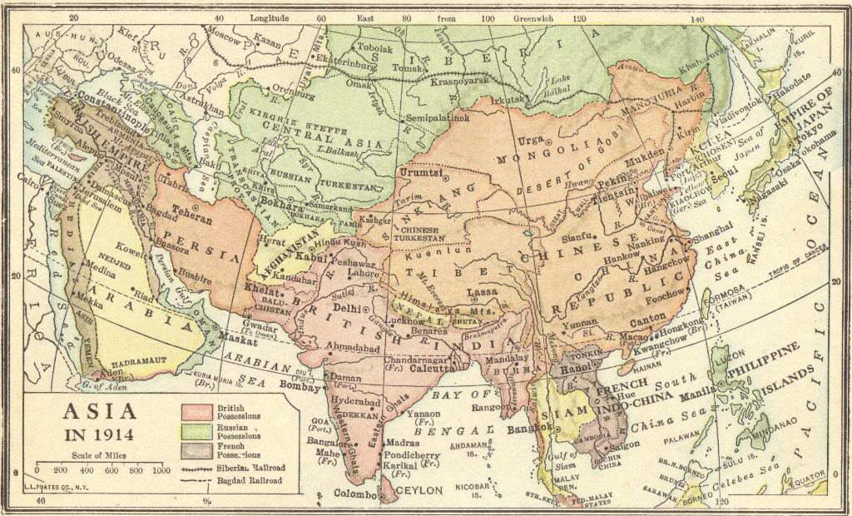

Imperialism in Asia
Map of the British, French, Russian, American, and Japanese colonial possessions in Asia at the start of World War I in 1914, as well as the Berlin-to-Baghdad and Siberian railroads.

